Land Use in Humboldt County
  - By: Jim Graham
  - 13th of September, 2013

Abstract
This paper is intended to serve as both a template and an example of the sort of content that belongs in each section. Reports need to start with a summary of the key points, sort of like a movie trailer. A good strategy for building it is to select a sentence or two from each section that really capture that component. In scholarly reports, it’s called an abstract, but in professional reports it may be called an executive summary. Either way, it’s meant to give the reader a quick look at what is in this paper.
Humboldt County, in the northwestern corner of California, has a reputation for being heavily forested. In this fake land use study, we’ll take a quick look at land use practices in Humboldt, and then evaluate actual land use to determine if this perception is well-founded, and if current land use practices are maintaining, increasing or decreasing the forest cover.

Introduction
An introduction typically includes background information on the topic and typically ends with the goals of the report. You may want to start by restating the purpose of the lab assignment, and perhaps the learning objectives for the lab, in your own words. Essentially, this part is to describe the scope of the study/lab, and what you hope to learn.
Humboldt County is one of the most northerly counties in California and is bordered by the Pacific Ocean and the Klamath Mountain Range (Figure 1). The county is rich in history, agriculture, industry, and educational institutions. As a rule of thumb, maps for reports should be no larger than six inches in any direction. For reports submitted in this class, a locator map should typically be four inches square (4” x 4”) and detail maps should be six inches square (6” x 6”). A more complete description of how to make and format these maps can be found on the Geospatial (GSP) Website, under Creating Reports in MS-Word that Contain Spatial Data.
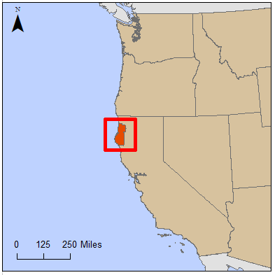
Figure 1 Map showing the location of Humboldt County within California. You can insert it as a line of text, or use the Insert > Caption feature. This is also the place to cite sources (Rock, 2016).
The Humboldt County Planning Commissions General Plan outlines the land use practices for each parcel within the county (Planning Commission, 2008). You should also reference background material that provided the foundation for this study, and cite it appropriately (Marris, 1982). This would be a nice lead in to a little background information on your data sources here, but detailed discussion of collection or evaluation methods should be reserved for the Methods section.

Methods
Your methods section should contain a narrative or summary of the steps performed during the lab assignment. You should describe the techniques and the tools you used to complete your work. This is also the place to discuss in detail how your data was collected or manipulated prior to, and during, analysis. Make sure that you cite all sources, including website addresses if the data was downloaded. It’s also important to include the date of the source in appropriate citation format. More information on correct use of citations can be obtained from the “Citing Your Sources” library guide, last modified December 7, 2015 (http://libguides.humboldt.edu/cite). Acronyms and short names should always be identified on first use, for your information (FYI). Thereafter, you may use the acronym or abbreviation by itself.
County boundary and land use data sets were downloaded from the Humboldt County web site (humboldtgov.org). Additional background layers for states and countries were obtained from the National Atlas web site (www.nationalatlas.gov) and the Natural Earth web site (www.naturalearthdata.com). In an actual report, the date these files were created or updated might also be mentioned, if relevant to the analysis.
Qualification of the data, calculations, and preparation of the maps were performed in ArcMap version 10.1 (ESRI, 2012). Additional calculations were performed in Microsoft Excel 2010. The GNU Image Manipulation Program (GIMP) version 2.8 (www.gimp.org) and Microsoft PowerPoint 2010 were used for preparation of the final maps.
All data was first checked to see if it was properly georeferenced using 24,000 scale digital raster graphics from TopoQuest (www.topoquest.com). Then, all data was projected into World Geodetic System 1984 (WGS 84) datum and the University Transverse Mercator, Zone 10 North, projection. Calculations were based on the existing entries in the attribute tables. You should provide enough detail for someone to follow what you did, but it should not read like a step-by-step instruction manual. Save information on what your analysis revealed for the results section.

Results
The results section is where you should place your final output. In the case of lab reports, any of the graded components of the lab assignment will belong here, including charts, tables, and maps. In your opening paragraph, you should summarize the results of the lab assignment in your own words.
Land use in Humboldt County is dominated by timber at over 57%, followed by open lands at 25%, and Tribal lands at 4%. Agriculture makes up just over 2% and all other categories of land use are below 1% (Table 1).
Table 1 Summary of land use within Humboldt County
Land Use Type | Number of Parcels | Number of Acres | Percent of the Total
Agriculture | 196 | 2713 | 2.1
Religious | 1458 | 50046 | 0.01
Urban | 103 | 400 | 0.7
Industry | 22420 | 17333 | 0.09
Open | 1191 | 1794 | 25
Residential | 103 | 2094 | 5.0
Timber | 3005 | 581221 | 57
Commercial | 1077 | 14480 | 0.08
Public | 23165 | 115593 | 0.6
Tribal | 8026 | 1312892 | 4.0

Timber land is spread throughout Humboldt County with tribal and open space dominating only in the northeast corner of the county (Figure 2). This confirms the perception held by others (Minca, 2007).
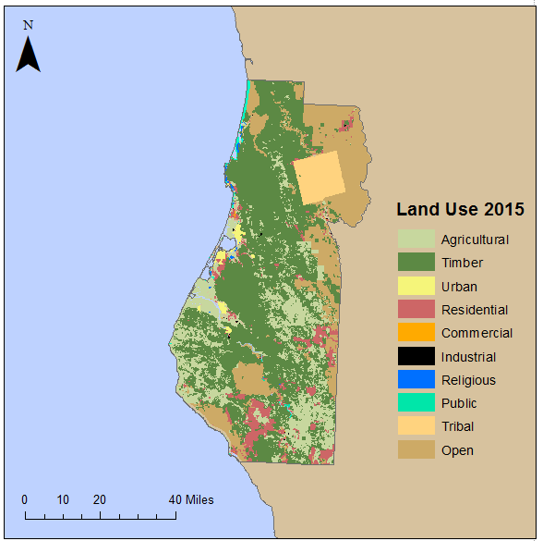
Figure 2 Land use within Humboldt County (Source: Humboldt County GIS)

Conclusion
This report shows that Humboldt County is dominated by timber and open lands. This confirms the counties reputation for large, productive, and beautiful forests. The conclusion should summarize the lab assignment as well as your own thoughts or insights about the lab, including ways in which it might be improved. It may be a good idea to restate the learning objectives and comment on whether or not you felt they have been met.
This short report is provided as an example of how to represent spatial information in a document created with Microsoft Word. The land use types are from the Humboldt County web site and are estimates of the actual land use practices. Thus, the results presented here will include uncertainty associated with these estimates. Additional work could further refine these estimates by including more detailed data.

Acknowledgements
This section is optional, but should be included if you have received funding or other assistance in conducting this research. Data for this study were provided by the Humboldt County GIS Department, Natural Earth, and the National Atlas. Funding, computer access and other facilities were provided by Humboldt State University.

Bibliography
Planning Commission, “Humboldt 21st Century: General Plan”, Humboldt County Website, Humboldt County Planning Division, March 13th, 2008, < http://co.humboldt.ca.us/gpu/documentsplan.aspx>
Marris, P, 1982, Community planning and conceptions of change, Routledge & Kegan Paul, ISBN 0710093497.
Minca, C., 2007, Humboldt's Compromise, or the Forgotten Geographies of Landscape, Progress in Human Geography, Volume 31, Issue 2, Pages 179-193.

